CUSTOMER MASTER ENTRY VIA EIP

NOTES (03/23/2015):
- You MUST make sure no viable customer record already exists in the master BEFORE entering a new one.
- You may ONLY use a Z-Copy for Customer #’s 10 through 29 to a new customer. All others are now prohibited in order to cut down on errors.
- You may search on any number of fields listed in the drop down box for your log in. This is an example of mine (Figure 1):
Figure 1 -> 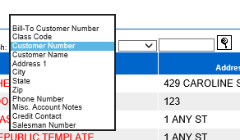
- Use asterisks before and/or after the data you key on the search field. Do NOT type full names/addresses, etc. or you likely will not find it.
- ALL SGMS customers must follow the 5000000 numbering convention. NO EXCEPTIONS!
- Comments & phone numbers do NOT go in the address field. Customer/order comment documents exist for that purpose. See page 2.
- Magnifying glass next to any field indicates that it is searchable.
- There is no longer access to the Customer Master via green screen. You must use EIP!
- If a customer is obsolete or no longer in business or not to be used, you MUST change the customer class code to XX. You also must change the ALPHA to *DNU. Their terms MUST be changed to 8 (Credit Card).

It is IMPERATIVE that we have clean data. Many people who rely on financial, sales, inventory and other reports are not able to get accurate data when it is not clean.

